INDEX

TITLES PAGE NO
CONTENTS
ABSTRACT vi
- INTRODUCTION 1
- LITERATURE SURVEY 5
2.1 KEY-DEDUPLICATION WITH IBBE 5
2.2 SERVER LESS DISTRIBUTEDFILESYSTEM 6
2.3 THE GOOGLEFILESYSTEM 7
2.4 CONVERGENTKEYMANAGEMENT 8
2.5 SOFTWAREENVIRONMENT 9
2.6 WHY CHOOSEPYTHON 10
- SYSTEM ANALYSIS 14
3.1 EXISTING SYSTEM 16
3.2 PROPOSEDSYSTEM 16
- FEASIBILITYSTUDY 17
4.1 ECONOMICALFEASIBILITY 17
4.2 TECHNICALFEASIBILITY 17
4.3 SOCIALFEASIBILITY 18
- SYSTEMREQUIREMENTS 19

SYSTEMDESIGN 20
6.1 SYSTEMARCHITECTURE 20
6.2 DATAFLOW DIAGRAM 20
6.3 UMLDIAGRAMS 22

IMPLEMENTATION 27
7.1 MODULES 27
7.2 SAMPLE CODE 28

SYSTEMTESTING 29
8.1 UNITTESTING 31
8.2 INTEGRATION TESTING 32
8.3 ACCEPTANCETESTING 33

INPUT DESIGN ANDOUTPUTDESIGN 34
9.1 INPUTDESIGN 34
9.2 OUTPUTDESIGN 35

SCREENSHOTS 37

FUTUREWORK 50

CONCLUSION 51

BIBLOGRAPHY 52

ABSTRACT:
Accidents have been a major cause of deaths in India. More than 80% of accident-related deaths occur not due to the accident itself but the lack of timely help reaching the accident victims. In highways where the traffic is really light and fast-paced an accident victim could be left unattended for a long time. The intent is to create a system which would detect an accident based on the live feed of video from a CCTV camera installed on a highway. The idea is to take each frame of a video and run it through a deep learning convolution neural network model which has been trained to classify frames of a video into accident or non-accident. Convolutional Neural Networks has proven to be a fast and accurate approach to classify images. CNN based image classifiers have given accuracy's of more than 95% for comparatively smaller datasets and require less preprocessing as compared to other image classifying algorithms.

- INTRODUCTION
Over 1.3 million deaths happen each year from road accidents, with a further of about 25 to 65 million people suffering from mild injuries as a result of road accidents. In a survey conducted by the World Health Organisation (WHO) on road accidents based on the income status of the country, it is seen that low and middle-income or developing countries have the highest number of road accident related deaths. Developing countries have road accident death rate of about 23.5 per 100,000 population, which is much higher when compared to the 11.3 per 100,000 population for high-income or developed countries [1]. Over 90% of road traffic related deaths happen in developing countries, even though these countries have only half of the world’s vehicles. In India, a reported 13 people are killed every hour as victims to road accidents across the country. However, the real case scenario could be much worse as many accident cases are left unreported. With the present data, India is on the way to the number one country in deaths from road accidents due to the poor average record of 13 deaths every hour, which is about 140,000 per year [2]. An accident usually has three phases in which a victim can be found. First phase of an accident is when the death of the accident victim occurs within a few minutes or seconds of the accident, about 10% of accident deaths happen in this phase. Second phase of an accident is the time after an hour of the accident which has the highest mortality rate (75% of all deaths). This can be avoided by timely help reaching the victims. The objective is to help accident victims in this critical hour of need. Third phase of an accident occurs days or weeks after the accident, this phase has a death rate of about 15% and takes medical care and resources to avoid. Fig. 1. Comparative analysis of population, income and road accidents The main objective is to incorporate a system which is able to detect an accident form video footage provided to it using a camera. The system is designed as a tool to help out accident victims in need by timely detecting an accident and henceforth informing the authorities of the same. The focus is to detect an accident within seconds of it happening using advanced Deep Learning Algorithms which use Convolutional Neural Networks (CNN’s or ConvNet) to analyze frames taken form the video generated by the camera.

We have focused on setting up this system on highways where the traffic is less dense and timely help reaching the accident victims is rare. On highways we can setup CCTV camera’s placed at distance of about 500 meters which act as a medium for surveillance, on this camera we can set up the proposed system which takes the footage from the CCTV camera’s and runs it on the propsed accident detection model in order to detect accidents. In this system, we have a Raspberry Pi 3 B+ Model which acts as a portable and remote computer to be set up on a CCTV camera. For demonstration purposes, we will be using a Pi Camera which can be directly set up on a Raspberry Pi. We have pre-trained an Inception v3 model to be able to detect accidents by training it on two different sets of images and sequence of video frames. The images and video frames are 10,000 severe accident frames and 10,000 non-accident frames. The Inception v3 algorithm can now detect an image or frames of a video to be an accident frame by up to 98.5% accuracy. This model was then implemented on a Raspberry Pi using TensorFlow, OpenCV and Keras. When a video is shown to the Raspberry Pi through the Pi camera, it runs each frame of the video through the model created and then predicts whether the given frame is an accident frame or not. If the prediction exceeds a threshold of 60% or 0.6 the Raspberry Pi then initiates the GSM module setup with it to send a message to the nearest hospital and police station, informing them about the accident which has been detected with the timestamp of when it occurred, the location of where it occurred, and the frame at which the accident was detected for further analyses. Also, an emergency light lights up. The system we have made can detect accidents to an accuracy of about 95.0%. It can be done on a Raspberry Pi which is a card-sized computer, which makes it easily portable and remote. The system developed can act as a reliable source of information in detecting accidents which can be done automatically. This project would help us in reducing the ginormous number of road accident related deaths that occur in our country.

2. LITERATURE SURVEY

2.1 An enhanced accident detection and victim status indicating system: Prototype

Authors: Prabakar, S., et al.

Abstract: In the speedy moving world, nobody is ready to look what's happening around them. Even when there occurs an accident nobody cares about it. This is an intention to implement an innovative solution for this problem by developing an Enhanced Accident detection System for Indicating Victim Status from the accident zone. This system has been developed and implemented using the biomedical smart sensors and microcontroller based mobile technology integrated with the evolving LabVIEW platform. The system will automatically identify the accident, then immediately transmit the location of the accident and the status of the physiological parameters of the victims to the emergency care center phone number through Short Message Service (SMS). The victim's physiological parameters such as body temperature, Heartbeat, Coma stage recovery status have been transmitted in the SMS. So the proposed system ensures that to reduce the human death ratio by accidents. When the accident occurs and realizes that there is no severe collision, then the person involved in accident has to press the switch provision which has been made to indicate that the accident is diminutive and no communication will be established i.e. no further alarming SMS has been transmitted.

2.2 Car Accident Detection and Notification System Using Smartphone

Authors: Hamid M. Ali,Zainab S. Alwan

Abstract: - Every day around the world, a large percentage of people die from traffic accident injuries. An effective approach for reducing traffic fatalities is: first building automatic traffic accident detection system, second, reducing the time between when an accident occurs and when first emergency responders are dispatched to the scene of the accident. Recent approaches are using built-in vehicle automatic accident detection and notification system. While these approaches work fine, they are expensive, maintenance complex task, and are not available in all cars. On the other hand, the ability to detect traffic accidents using smartphones has only recently become possible because of the advances in the processing power and sensors deployed on smartphones. Most of the smartphone based accident detection systems rely on the high speed of the vehicle (extracted from the smartphone GPS receiver) and the G-Force value (extracted from smartphone accelerometer sensor) to detect an accident. As many references assure that 90% of road-traffic accidents occur at low speed of the vehicle. Hence, in addition to the high speed accident detection, this paper concentrated on low speed car accident detection. The main obstacle that encounters the low speed accident is how to differentiate whether the user is inside the vehicle or outside the vehicle, walking or slowly running. The effect of this obstacle is minimized, in this work, by a proposed mechanism that distinguishes between the speed variation of low speed vehicle and walking or slowly running person. The proposed system consists of two phases; the detection phase which is used to detect car accident in low and high speeds. The notification phase, and immediately after an accident is indicated, is used to send detailed information such as images, video, accident location, etc. to the emergency responder for fast recovery. The system was practically tested in real simulated environment and achieved quite very good performance results.

2.3 Smart Car: An IoT Based Accident Detection System

Authors: Arif Shaik,Natalie Bowen,Jennifer Bole,Gary Kunzi Abstract: The Internet of Things (IoT) offers limitless possibilities to both the public and private sectors. Automobile manufacturers are interested in IoT applications to increase the safety of their vehicles, to meet customers' demands and ultimately to offer cutting-edge products which maximize profit. The healthcare industry is concerned with how the IoT can improve the speed and accuracy of communication. This paper describes the feasibility of equipping a vehicle with technology that can detect an accident and immediately alert emergency personnel. When there is a car accident someone has to actively seek help such as calling 911 for emergency services. There is no automatic notification to the police, ambulance, friends, or family. The Internet of Things (IoT) can be used to produce an automatic notification and response to the scene. A signal from an accelerometer and a GPS sensor are automatically sent to the cloud and from there, an alert message will be received by whoever is subscribed to that car. The signal will indicate the severity of the accident and the GPS location. The ambulance will use the GPS coordinates to get to the scene quickly.

2.4 Vehicle to Vehicle communication

Authors: Shagufta Ali Abstract: Vehicle to Vehicle communicationA robust wireless network of connected vehicles is needed to enable future telematics and infotainment applications in the vehicular domain. We need to focus on terms reliable and continuous system performances as vehicle to vehicle (V2V) faces a highly dynamic time-varying channel conditions and varying vehicle network topology. This paper mainly focuses on Wireless communication technologies used in v2v communication .Keeping in mind the terms reliability, scalability, latency and throughput of the system, the technologies we have focused on are Cellular vehicle to everything communication (C-V2X), 4rth Generation Long term evaluation (4G-LTE) and Dedicated short range communication (DSRC). Also we have discussed the technical challenges v2v is facing. Further, we propose three methods related to high speed vehicles mobility and complex channel environment along with vehicle network topological variations Loss differentiation Rate Adaption (LORA) is a scheme proposed to approximate the average packet loss rate (PLR) for every sender and select a data rate based on PLR. Exponential Effective SNR Mapping (EESM) and Mutual Information Effective SNR Mapping (MIESM) are two Adaptive modulation and coding mechanisms used for data rate selection according to current channel conditions. In order to adjusts and modify the data rate between vehicles according to the number of connectable vehicles nearby, a physical topology-triggered adaptive transmission scheme is proposed. Reliability and more continuous data transmission for V2V communications can be ensured by these methods and it can be proved by Extensive evaluation results. As a result, the effective improvement in performance on network throughput can be observed.

2.5 SOFTWARE ENVIRONMENT
Python is a high-level, interpreted scripting language developed in the late 1980s by Guido van Rossum at the National Research Institute for Mathematics and Computer Science in the Netherlands. The initial version was published at the alt. Sources newsgroup in 1991, and version 1.0 was released in 1994.
Python 2.0 was released in 2000, and the 2.x versions were the prevalent releases until December 2008. At that time, the development team made the decision to release version 3.0, which contained a few relatively small but significant changes that were not backward compatible with the 2.x versions. Python 2 and 3 are very similar, and some features of Python 3 have been back ported to Python 2. But in general, they remain not quite compatible.
Both Python 2 and 3 have continued to be maintained and developed, with periodic release updates for both. As of this writing, the most recent versions available are 2.7.15 and 3.6.5. However, an official End of Life date of January 1, 2020 has been established for Python 2, after which time it will no longer be maintained. If you are a newcomer to Python, it is recommended that you focus on Python 3, as this tutorial will do.
Python is still maintained by a core development team at the Institute, and Guido is still in charge, having been given the title of BDFL (Benevolent Dictator For Life) by the Python community. The name Python, by the way, derives not from the snake, but from the British comedy troupe Monty Python’s Flying Circus, of which Guido was, and presumably still is, a fan. It is common to find references to Monty Python sketches and movies scattered throughout the Python documentation.

2.6 WHY CHOOSE PYTHON
If you’re going to write programs, there are literally dozens of commonly used languages to choose from. Why choose Python? Here are some of the features that make Python an appealing choice.

Python is Popular
Python has been growing in popularity over the last few years. The 2018 Stack Overflow Developer Survey ranked Python as the 7th most popular and the number one most wanted technology of the year. World-class software development countries around the globe use Python every single day.
According to research by Dice Python is also one of the hottest skills to have and the most popular programming language in the world based on the Popularity of Programming Language Index.
Due to the popularity and widespread use of Python as a programming language, Python developers are sought after and paid well. If you’d like to dig deeper into Python salary statistics and job opportunities, you can do so here.
Python is interpreted
Many languages are compiled, meaning the source code you create needs to be translated into machine code, the language of your computer’s processor, before it can be run. Programs written in an interpreted language are passed straight to an interpreter that runs them directly.
This makes for a quicker development cycle because you just type in your code and run it, without the intermediate compilation step.
One potential downside to interpreted languages is execution speed. Programs that are compiled into the native language of the computer processor tend to run more quickly than interpreted programs. For some applications that are particularly computationally intensive, like graphics processing or intense number crunching, this can be limiting.
In practice, however, for most programs, the difference in execution speed is measured in milliseconds, or seconds at most, and not appreciably noticeable to a human user. The expediency of coding in an interpreted language is typically worth it for most applications.

Python is Free
The Python interpreter is developed under an OSI-approved open-source license, making it free to install, use, and distribute, even for commercial purposes.
A version of the interpreter is available for virtually any platform there is, including all flavors of Unix, Windows, macOS, smart phones and tablets, and probably anything else you ever heard of. A version even exists for the half dozen people remaining who use OS/2.

Python is Portable
Because Python code is interpreted and not compiled into native machine instructions, code written for one platform will work on any other platform that has the Python interpreter installed. (This is true of any interpreted language, not just Python.)

Python is Simple
As programming languages go, Python is relatively uncluttered, and the developers have deliberately kept it that way.
A rough estimate of the complexity of a language can be gleaned from the number of keywords or reserved words in the language. These are words that are reserved for special meaning by the compiler or interpreter because they designate specific built-in functionality of the language.
Python 3 has 33 keywords, and Python 2 has 31. By contrast, C++ has 62, Java has 53, and Visual Basic has more than 120, though these latter examples probably vary somewhat by implementation or dialect.
Python code has a simple and clean structure that is easy to learn and easy to read. In fact, as you will see, the language definition enforces code structure that is easy to read.
But It’s Not That Simple For all its syntactical simplicity, Python supports most constructs that would be expected in a very high-level language, including complex dynamic data types, structured and functional programming, and object-oriented programming.
Additionally, a very extensive library of classes and functions is available that provides capability well beyond what is built into the language, such as database manipulation or GUI programming.
Python accomplishes what many programming languages don’t: the language itself is simply designed, but it is very versatile in terms of what you can accomplish with it.

Conclusion
This section gave an overview of the Python programming language, including:
- A brief history of the development of Python
- Some reasons why you might select Python as your language of choice
Python is a great option, whether you are a beginning programmer looking to learn the basics, an experienced programmer designing a large application, or anywhere in between. The basics of Python are easily grasped, and yet its capabilities are vast. Proceed to the next section to learn how to acquire and install Python on your computer.
Python is an open source programming language that was made to be easy-to-read and powerful. A Dutch programmer named Guido van Rossum made Python in 1991. He named it after the television show Monty Python's Flying Circus. Many Python examples and tutorials include jokes from the show.
Python is an interpreted language. Interpreted languages do not need to be compiled to run. A program called an interpreter runs Python code on almost any kind of computer. This means that a programmer can change the code and quickly see the results. This also means Python is slower than a compiled language like C, because it is not running machine code directly.
Python is a good programming language for beginners. It is a high-level language, which means a programmer can focus on what to do instead of how to do it. Writing programs in Python takes less time than in some other languages.
Python drew inspiration from other programming languages like C, C++, Java, Perl, and Lisp.
Python has a very easy-to-read syntax. Some of Python's syntax comes from C, because that is the language that Python was written in. But Python uses whitespace to delimit code: spaces or tabs are used to organize code into groups. This is different from C. In C, there is a semicolon at the end of each line and curly braces ({}) are used to group code. Using whitespace to delimit code makes Python a very easy-to-read language.
Python use [change / change source]
Python is used by hundreds of thousands of programmers and is used in many
places. Sometimes only Python code is used for a program, but most of the time it is used to do simple jobs while another programming language is used to do more complicated tasks.
Its standard library is made up of many functions that come with Python when it is installed. On the Internet there are many other libraries available that make it possible for the Python language to do more things. These libraries make it a powerful language; it can do many different things.
Some things that Python is often used for are:
- Web development
- Scientific programming
- Desktop GUIs
- Network programming
- Game programming

3. SYSTEM ANALYSIS
3.1 EXISTING SYSTEM:
we have tried to compare our work with other accident detection techniques. Most of the studies in this field revolve around the enhancement of tangible infrastructure rather than on Intelligent Transportation Systems (ITS) which include traffic congestion detection, accident detection, detecting the occurrence of an event etc. Even the few existing studies in the domain lack implementation details and are terrain specific i.e. there are constraints both in the geographical as well as demographic aspects

DISADVANTAGES OF EXISTING SYSTEM:
1. More than 80% of accident-related deaths occur not due to the accident itself but the lack of timely help reaching the accident victims

3.2 PROPOSED SYSTEM:
The proposed model is a fusion of CNN and LSTM layers for continuous video classification taken from a camera. The CNN part of the proposed model was mainly inspired by the Inception v3, but with certain tweaks it has fitted well to our training images. The LSTM layers were added to the existing Convolution Network to take into account temporal features along with spatial features. This is further divided into the convolution and recurrent parts of the model. In a CNN-LSTM network, the CNN is primarily used for feature extraction from the images, which is passed on to the LSTM for sequence prediction. They are widely used in tasks similar to Activity Recognition, Image Description, Video Description etc.

ADVANTAGES OF PROPOSED SYSTEM:

1.Initially, the model had difficulties in predicting the right class since the only difference between cars and broken cars were dents, broken headlights etc.
2.Thus, random noise was being accounted during the prediction since not all the accident images were of high clarity.

4. FEASIBILITY STUDY
The feasibility of the project is analyzed in this phase and business proposal is put forth with a very general plan for the project and some cost estimates. During system analysis the feasibility study of the proposed system is to be carried out. This is to ensure that the proposed system is not a burden to the company. For feasibility analysis, some understanding of the major requirements for the system is essential.
Three key considerations involved in the feasibility analysis are
- ECONOMICAL FEASIBILITY
- TECHNICAL FEASIBILITY
- SOCIAL FEASIBILITY

4.1 ECONOMICAL FEASIBILITY
This study is carried out to check the economic impact that the system will have on the organization. The amount of fund that the company can pour into the research and development of the system is limited. The expenditures must be justified. Thus the developed system as well within the budget and this was achieved because most of the technologies used are freely available. Only the customized products had to be purchased.
4.2 TECHNICAL FEASIBILITY
This study is carried out to check the technical feasibility, that is, the technical requirements of the system. Any system developed must not have a high demand on the available technical resources. This will lead to high demands on the available technical resources. This will lead to high demands being placed on the client. The developed system must have a modest requirement, as only minimal or null changes are required for implementing this system.
4.3 SOCIAL FEASIBILITY
The aspect of study is to check the level of acceptance of the system by the user. This includes the process of training the user to use the system efficiently. The user must not feel threatened by the system, instead must accept it as a necessity. The level of acceptance by the users solely depends on the methods that are employed to educate the user about the system and to make him familiar with it. His level of confidence must be raised so that he is also able to make some constructive criticism, which is welcomed, as he is the final user of the system.

5. SYSTEM REQUIREMENTS

5.1 HARDWARE REQUIREMENTS:

- System : Pentium Dual Core.
- Hard Disk : 120 GB.
- Monitor : 15’’ LED
- Input Devices : Keyboard, Mouse
- Ram : 1 GB

5.2 SOFTWARE REQUIREMENTS:

- Operating system : Windows 10
- Coding Language : python
- Tool : PyCharm
- Database : MYSQL
- Server : Flask

6. SYSTEM DESIGN

6.1 SYSTEM ARCHITECTURE:
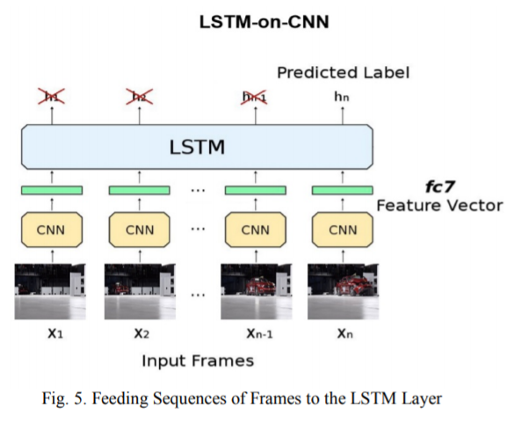

6.2 DATA FLOW DIAGRAM:

- The DFD is also called as bubble chart. It is a simple graphical formalism that can be used to represent a system in terms of input data to the system, various processing carried out on this data, and the output data is generated by this system.
- The data flow diagram (DFD) is one of the most important modeling tools. It is used to model the system components. These components are the system process, the data used by the process, an external entity that interacts with the system and the information flows in the system.
- DFD shows how the information moves through the system and how it is modified by a series of transformations. It is a graphical technique that depicts information flow and the transformations that are applied as data moves from input to output.
- DFD is also known as bubble chart. A DFD may be used to represent a system at any level of abstraction. DFD may be partitioned into levels that represent increasing information flow and functional detail.

- 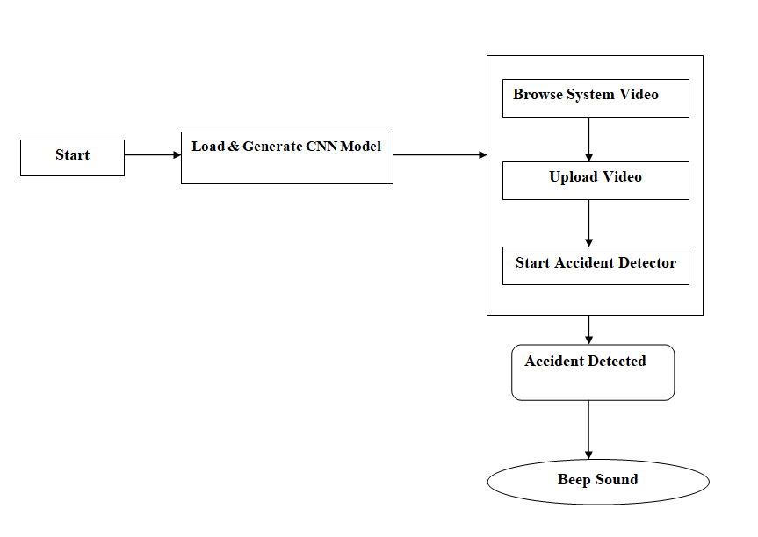

FLOW CHART
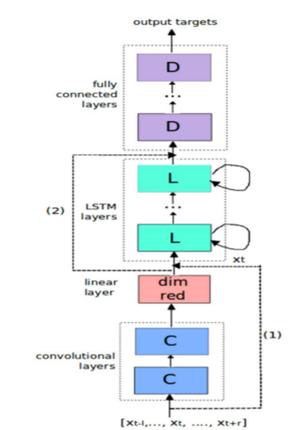

6.3 UML DIAGRAMS:
UML stands for Unified Modeling Language. UML is a standardized general-purpose modeling language in the field of object-oriented software engineering. The standard is managed, and was created by, the Object Management Group.
The goal is for UML to become a common language for creating models of object oriented computer software. In its current form UML is comprised of two major components: a Meta-model and a notation. In the future, some form of method or process may also be added to; or associated with, UML.
The Unified Modeling Language is a standard language for specifying, Visualization, Constructing and documenting the artifacts of software system, as well as for business modeling and other non-software systems.
The UML represents a collection of best engineering practices that have proven successful in the modeling of large and complex systems.
The UML is a very important part of developing objects oriented software and the software development process. The UML uses mostly graphical notations to express the design of software projects.

GOALS:
The Primary goals in the design of the UML are as follows:
- Provide users a ready-to-use, expressive visual modeling Language so that they can develop and exchange meaningful models.
- Provide extendibility and specialization mechanisms to extend the core concepts.
- Be independent of particular programming languages and development process.
- Provide a formal basis for understanding the modeling language.
- Encourage the growth of OO tools market.
- Integrate best practices.

USE CASE DIAGRAM:
A use case diagram in the Unified Modeling Language (UML) is a type of behavioral diagram defined by and created from a Use-case analysis. Its purpose is to present a graphical overview of the functionality provided by a system in terms of actors, their goals (represented as use cases), and any dependencies between those use cases. The main purpose of a use case diagram is to show what system functions are performed for which actor. Roles of the actors in the system can bedepicted.
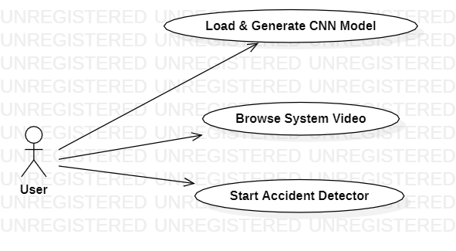
CLASS DIAGRAM:
In software engineering, a class diagram in the Unified Modeling Language (UML) is a type of static structure diagram that describes the structure of a system by showing the system's classes, their attributes, operations (or methods), and the relationships among the classes. It explains which class contains information.
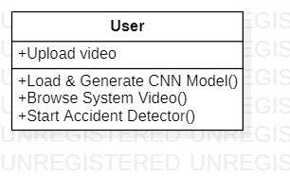

SEQUENCE DIAGRAM:
A sequence diagram in Unified Modeling Language (UML) is a kind of interaction diagram that shows how processes operate with one another and in what order. It is a construct of a Message Sequence Chart. Sequence diagrams are sometimes called event diagrams, event scenarios, and timing diagrams.
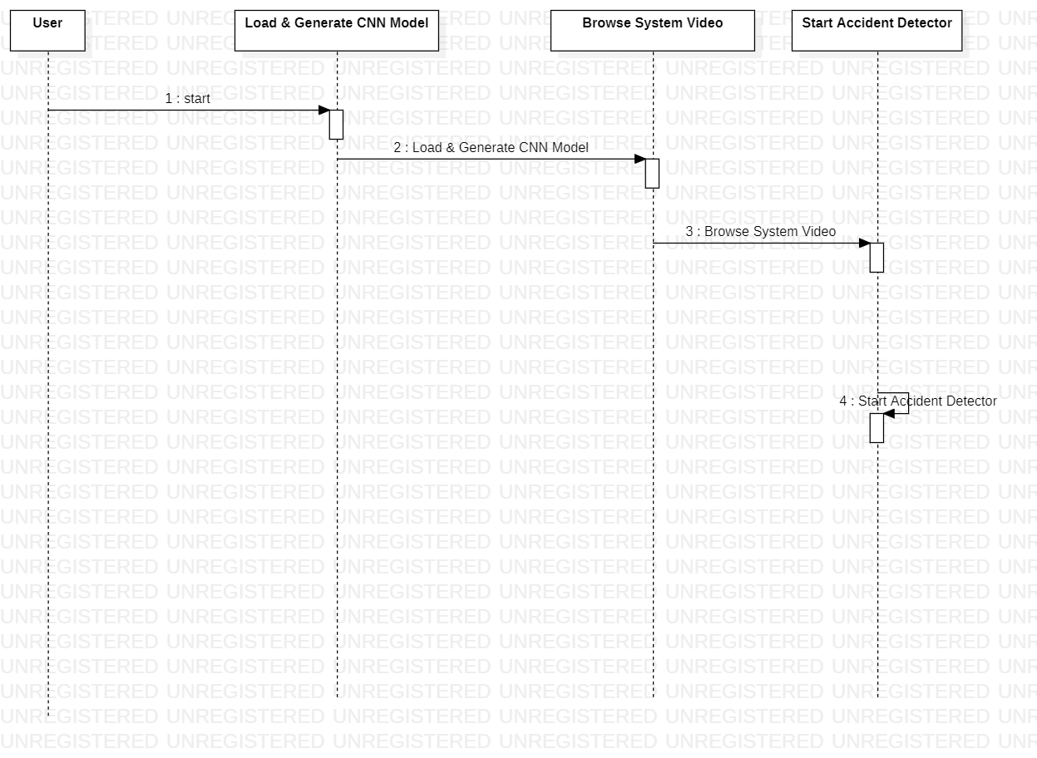

ACTIVITY DIAGRAM:
Activity diagrams are graphical representations of workflows of stepwise activities and actions with support for choice, iteration and concurrency. In the Unified Modeling Language, activity diagrams can be used to describe the business and operational step-by-step workflows of components in a system. An activity diagram shows the overall flow of control.
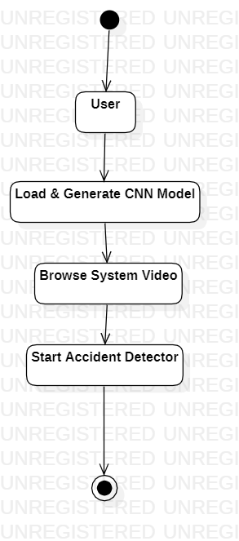

7. IMPLEMENTATION

7.1 MODULES:
- Load & Generate CNN Model
- Browse System Video
- Start Accident Detector

MODULES DESCRIPTION:
1.Load & Generate CNN Model
In this module we load and trained CNN with dataset.

2. Browse System Video
In this module user upload video to the system.

3. Start Accident Detector
In this module uploaded video is loaded ,start video play and detect accident

7.2 SAMPLE CODE

8. SYSTEM TESTING

The purpose of testing is to discover errors. Testing is the process of trying to discover every conceivable fault or weakness in a work product. It provides a way to check the functionality of components, sub assemblies, assemblies and/or a finished product It is the process of exercising software with the intent of ensuring that the Software system meets its requirements and user expectations and does not fail in an unacceptable manner. There are various types of test. Each test type addresses a specific testing requirement.

TYPES OF TESTS

Unit testing:
Unit testing involves the design of test cases that validate that the internal program logic is functioning properly, and that program inputs produce valid outputs. All decision branches and internal code flow should be validated. It is the testing of individual software units of the application .it is done after the completion of an individual unit before integration. This is a structural testing, that relies on knowledge of its construction and is invasive. Unit tests perform basic tests at component level and test a specific business process, application, and/or system configuration. Unit tests ensure that each unique path of a business process performs accurately to the documented specifications and contains clearly defined inputs and expected results.

Integration testing:
Integration tests are designed to test integrated software components to determine if they actually run as one program. Testing is event driven and is more concerned with the basic outcome of screens or fields. Integration tests demonstrate that although the components were individually satisfaction, as shown by successfully unit testing, the combination of components is correct and consistent. Integration testing is specifically aimed at exposing the problems that arise from the combination of components.

Functional test:
Functional tests provide systematic demonstrations that functions tested are available as specified by the business and technical requirements, system documentation, and user manuals.
Functional testing is centered on the following items:
Valid Input : identified classes of valid input must be accepted.
Invalid Input : identified classes of invalid input must be rejected.
Functions : identified functions must be exercised.
Output : identified classes of application outputs must be exercised.
Systems/Procedures : interfacing systems or procedures must be invoked.
Organization and preparation of functional tests is focused on requirements, key functions, or special test cases. In addition, systematic coverage pertaining to identify Business process flows; data fields, predefined processes, and successive processes must be considered for testing. Before functional testing is complete, additional tests are identified and the effective value of current tests is determined.

System Test:
System testing ensures that the entire integrated software system meets requirements. It tests a configuration to ensure known and predictable results. An example of system testing is the configuration oriented system integration test. System testing is based on process descriptions and flows, emphasizing pre-driven process links and integration points.

White Box Testing:
White Box Testing is a testing in which in which the software tester has knowledge of the inner workings, structure and language of the software, or at least its purpose. It is purpose. It is used to test areas that cannot be reached from a black box level.

Black Box Testing:
Black Box Testing is testing the software without any knowledge of the inner workings, structure or language of the module being tested. Black box tests, as most other kinds of tests, must be written from a definitive source document, such as specification or requirements document, such as specification or requirements document. It is a testing in which the software under test is treated, as a black box .you cannot “see” into it. The test provides inputs and responds to outputs without considering how the software works.
8.1 Unit Testing:
Unit testing is usually conducted as part of a combined code and unit test phase of the software lifecycle, although it is not uncommon for coding and unit testing to be conducted as two distinct phases.

Test strategy and approach:
Field testing will be performed manually and functional tests will be written in detail.

Test objectives:
- All field entries must work properly.
- Pages must be activated from the identified link.
- The entry screen, messages and responses must not be delayed.

Features to be tested
- Verify that the entries are of the correct format
- No duplicate entries should be allowed
- All links should take the user to the correct page.

8.2 Integration Testing
Software integration testing is the incremental integration testing of two or more integrated software components on a single platform to produce failures caused by interface defects.
The task of the integration test is to check that components or software applications, e.g. components in a software system or – one step up – software applications at the company level – interact without error.
Test Results: All the test cases mentioned above passed successfully. No defects encountered.

8.3 Acceptance Testing
User Acceptance Testing is a critical phase of any project and requires significant participation by the end user. It also ensures that the system meets the functional requirements.
Test Results: All the test cases mentioned above passed successfully. No defects encountered.

9. INPUT DESIGN AND OUTPUT DESIGN
9.1 INPUT DESIGN:
The input design is the link between the information system and the user. It comprises the developing specification and procedures for data preparation and those steps are necessary to put transaction data in to a usable form for processingcan be achieved by inspecting the computer to read data from a written or printed document or it can occur by having people keying the data directly into the system. The design of input focuses on controlling the amount of input required, controlling the errors, avoiding delay, avoiding extra steps and keeping the process simple. The input is designed in such a way so that it provides security and ease of use with retaining the privacy. Input Design considered the following things:
- What data should be given as input?
- How the data should be arranged or coded?
- The dialog to guide the operating personnel in providing input.
- Methods for preparing input validations and steps to follow when error occur.
OBJECTIVES:
1. Input Design is the process of converting a user-oriented description of the input into a computer-based system. This design is important to avoid errors in the data input process and show the correct direction to the management for getting correct information from the computerized system.
2.It is achieved by creating user-friendly screens for the data entry to handle large volume of data. The goal of designing input is to make data entry easier and to be free from errors. The data entry screen is designed in such a way that all the data manipulates can be performed. It also provides record viewing facilities.
3. When the data is entered it will check for its validity. Data can be entered with the help of screens. Appropriate messages are provided as when needed so that the user will not be in maize of instant. Thus the objective of input design is to create an input layout that is easy to follow
9.2 OUTPUT DESIGN:
A quality output is one, which meets the requirements of the end user and presents the information clearly. In any system results of processing are communicated to the users and to other system through outputs. In output design it is determined how the information is to be displaced for immediate need and also the hard copy output. It is the most important and direct source information to the user. Efficient and intelligent output design improves the system’s relationship to help user decision-making.
1. Designing computer output should proceed in an organized, well thought out manner; the right output must be developed while ensuring that each output element is designed so that people will find the system can use easily and effectively. When analysis design computer output, they should Identify the specific output that is needed to meet the requirements.
2. Select methods for presenting information.
3. Create document, report, or other formats that contain information produced by the system.
The output form of an information system should accomplish one or more of the following objectives.
- Convey information about past activities, current status or projections of the
- Future.
- Signal important events, opportunities, problems, or warnings.
- Trigger an action.
- Confirm an action.
10. SCREENSHOTS

To run project double click on run.bat file to get below screen
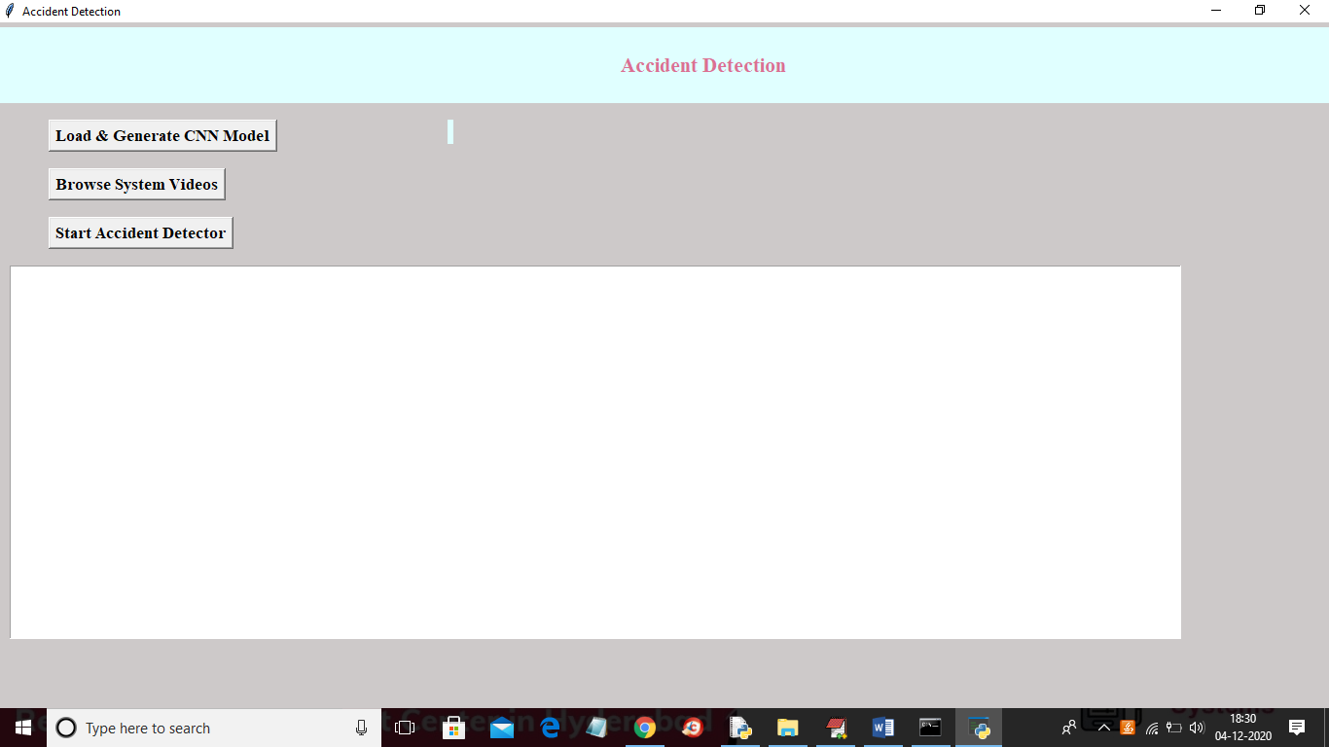
In above screen click on ‘Load & Generate CNN Model’ button to trained CNN with dataset and to load CNN model using tensorflow
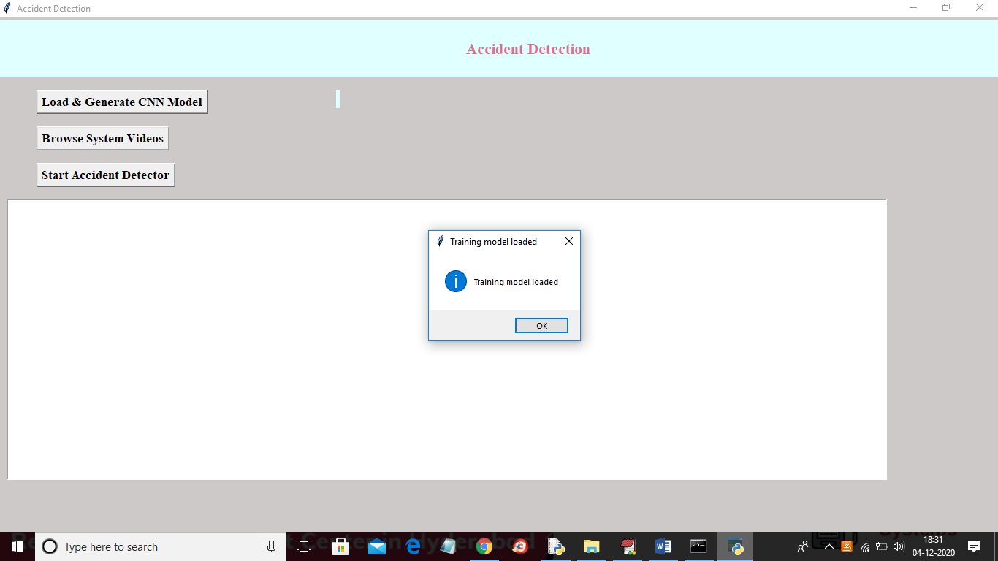
In above screen tensorflow model is loaded and now click on ‘Browse System Video’ button to upload video
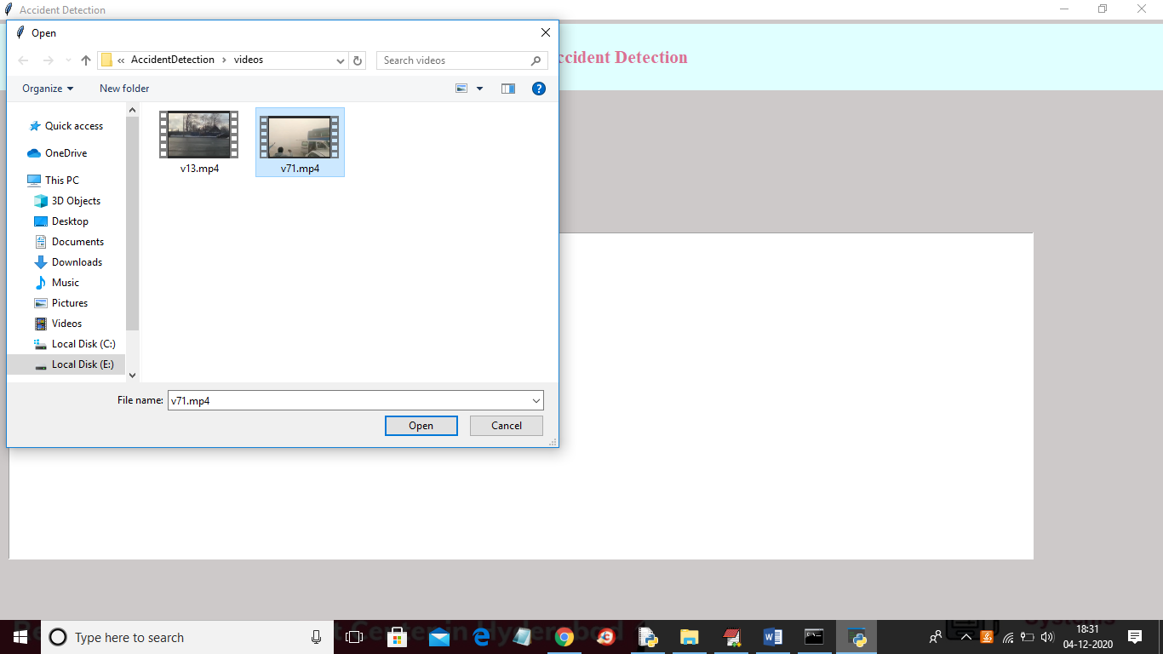
In above screen selecting and uploading video and then click on ‘Open’ button to load video
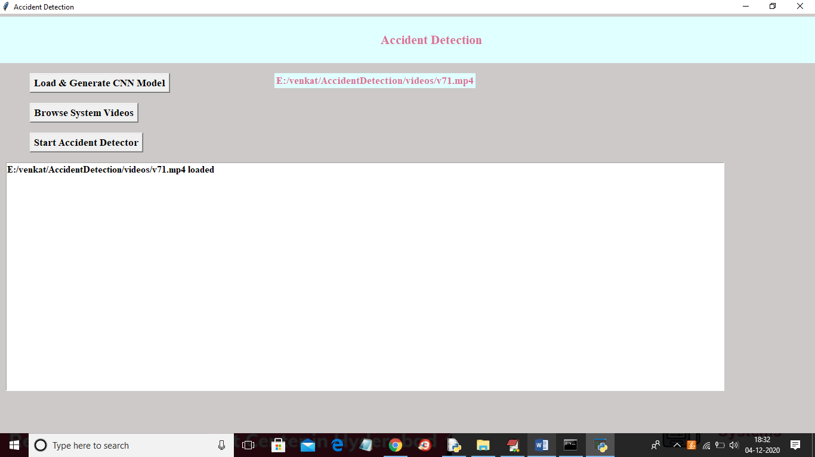
In above screen video is loaded and now click on ‘Start Accident Detector’ button to play video and detect accident
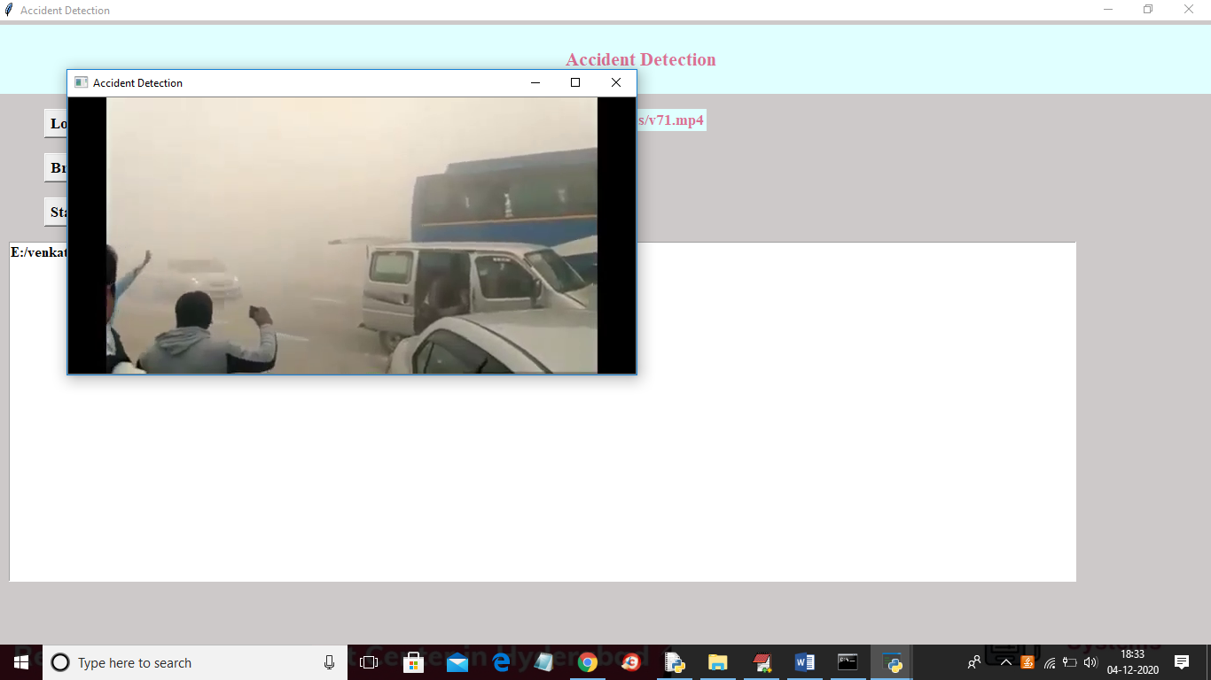
In above screen video start playing and upon accident detection will get below screen with beep sound
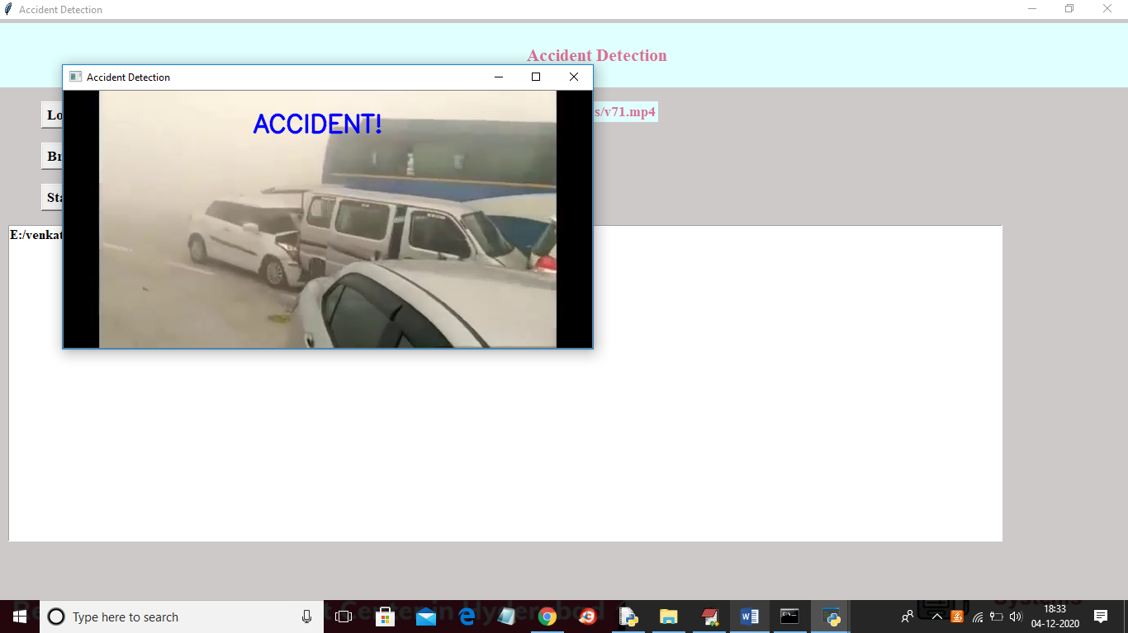
In below screen playing another video without message if normal driving appear
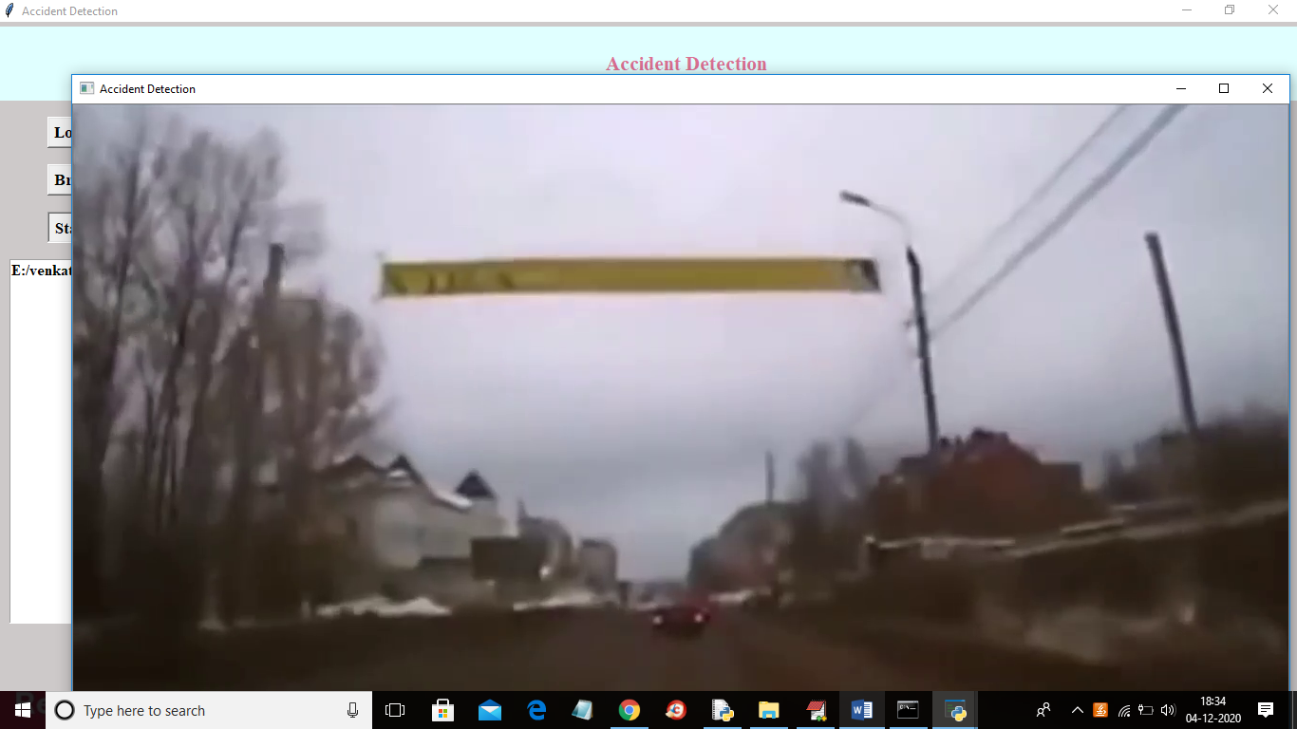
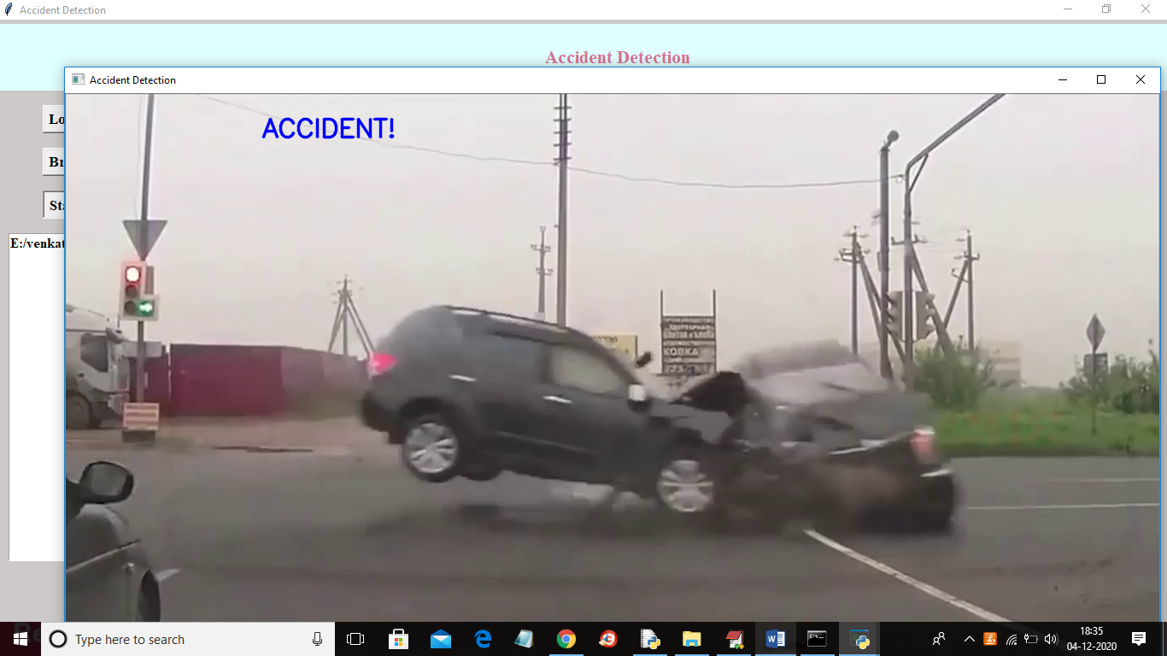
In above screen upon collision then accident display message will appear with beep sound
In below screen application is trained with below images
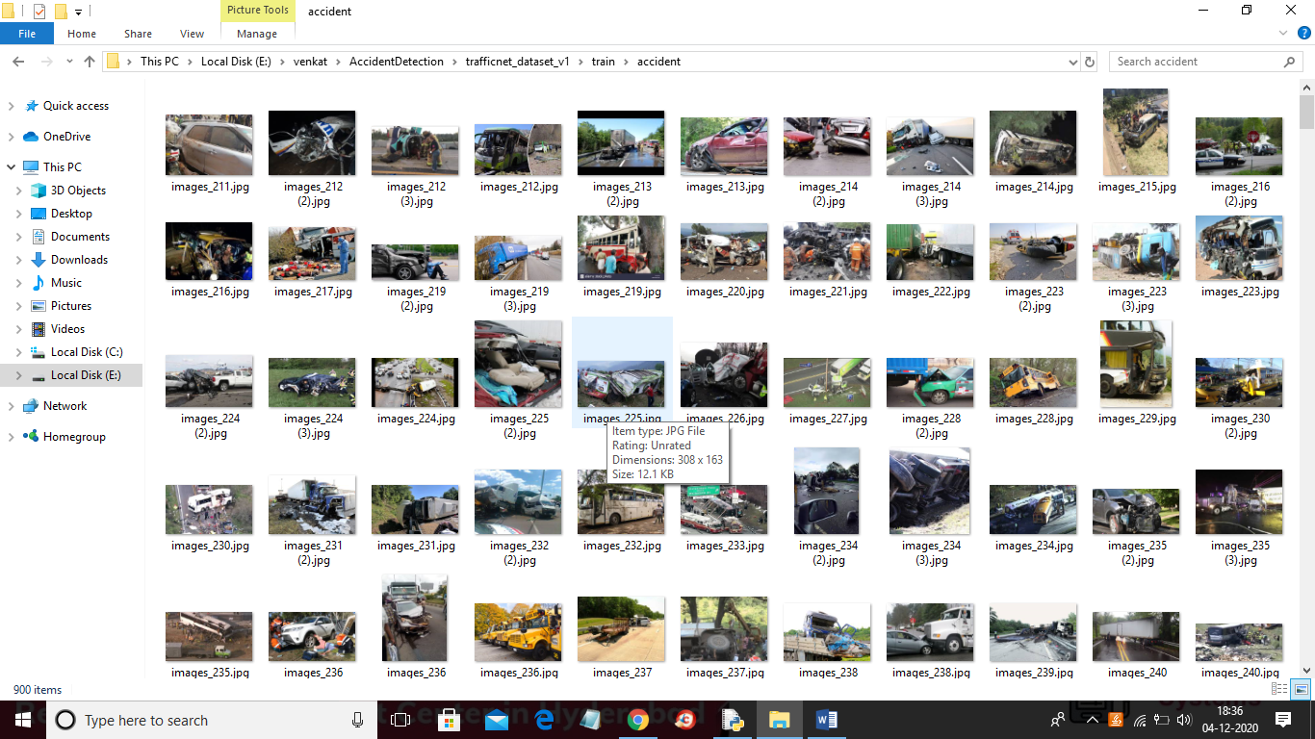

11. FUTURE ENHANCEMENT

Future Enhancement is being planned to further analyze and enhance the protocol towards a social cause and helps create a system which guarantees that no individual is left unattended or helpless in an unforeseen event of an accident, in turn, securing and maintaining the quality of life to the highest standards.

12. CONCLUSION
Accidents are one of the most common problems that humanity faces on a daily basis, leading to loss of both life as well as property. The proposed system provides a very viable and effective solution to this problem. The proposed vehicle accident detection system can track an accident at its moment of occurrence and sends an instantaneous alert SMS regarding the accident to the nearby hospitals and police stations which includes details like timestamp and the geographical location. Unlike other systems in use, which consists of expensive sensors and unwanted hardware, the proposed system is much more cost effective and foolproof with a much-improved accuracy rate than its counterparts mainly due to a model-based approach. The experimentation, testing and validation has been carried out using images and the results show that higher sensitivity and accuracy is indeed achieved using this method, henceforth, making it a viable option for implementing this system in most of the state and national highways of the country.

13. REFERENCES

[1] "Global status report on road safety 2015", World Health Organization, 2019. [Online]. Available: http://www.who.int/violence_injury_prevention/road_safety_status/20 15/en/. [Accessed: 07- Mar- 2019].
[2] Prabakar, S., et al. "An enhanced accident detection and victim status indicating system: Prototype." India Conference (INDICON), 2012 Annual IEEE. IEEE, 2012.
[3] "Lexus Enform", Lexus, 2019. [Online]. Available: https://www.lexus.com/enform. [Accessed: 07- Mar- 2019].
[4] "OnStar Safety and Security Services", Onstar.com, 2019. [Online]. Available: https://www.onstar.com/us/en/services/safety-security/. [Accessed: 07- Mar- 2019].
[5] "SOSmart automatic car crash detection and notification app", SOSmart automatic car crash detection app, 2019. [Online]. Available: http://www.sosmartapp.com. [Accessed: 07- Mar- 2019].
[6] C. Kockan, “Communication between vehicles” PhD thesis, Istanbul Technical University, 2008
[7] Zeng, Yuanyuan, Deshi Li, and Athanasios V. Vasilakos. "Opportunistic fleets for road event detection in vehicular sensor networks." Wireless Networks 22.2 (2016): 503-521.
[8] Szegedy, Christian, et al. "Rethinking the inception architecture for computer vision." Proceedings of the IEEE conference on computer vision and pattern recognition. 2016.
[9] Szegedy, Christian, et al. "Going deeper with convolutions." Proceedings of the IEEE conference on computer vision and pattern recognition. 2015.

